BUG REPORT OF MUSIC MADRAS
APP: MUSIC OF MADRASS
DEVICE : OPPOA37F
ANDROID VERSION : 5.1.1
APP VERSION: 1.14
DOWNLOAD SIZE : 5.60 MB
[PORTRAIT MODE]
1.MODULE/PATH : HOME PAGE
BUG : In home page organizer & favourites folder are not in strait line.

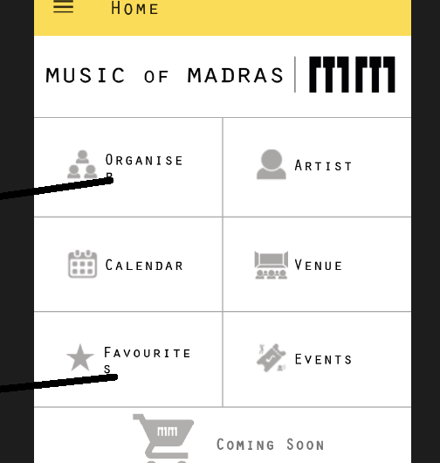

EXPECTED RESULT: Organizer & favourites folder are in strait line.
PRIORITY : low
2. MODULE/PATH : HOME PAGE
BUG:When we click on back button on device then menu bar not disappear.

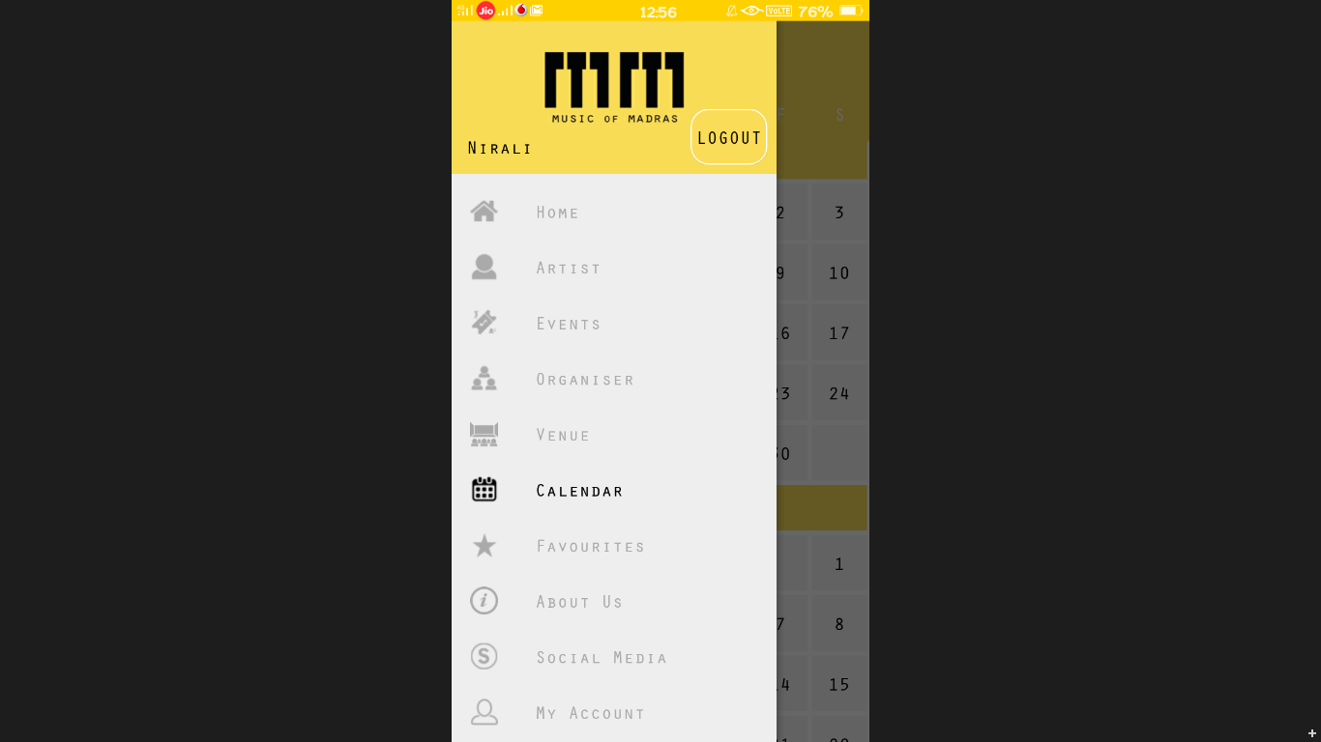

EXPECTED RESULT : menubar should disappear.
PRIORITY : Medium
3. MODULE/PATH : CALENDAR
BUG : Search box is not visible.

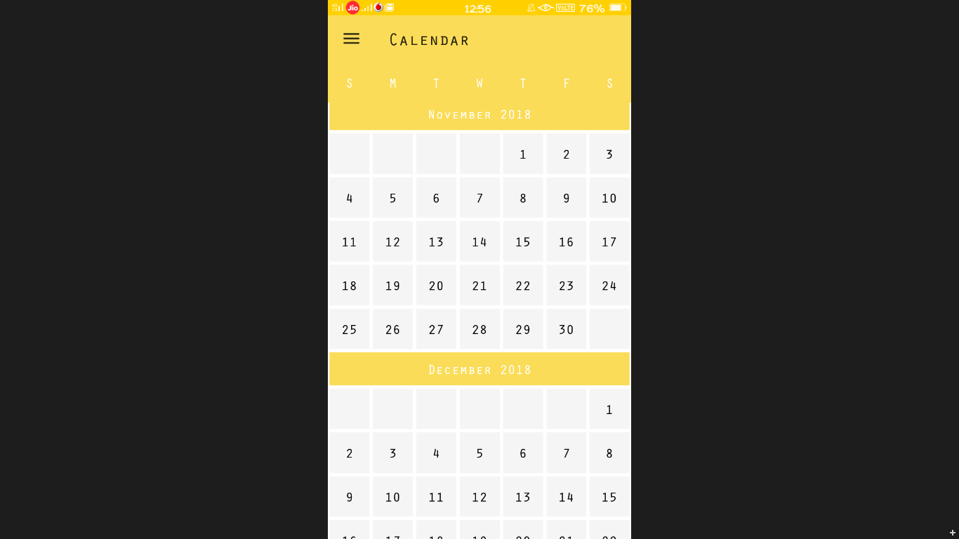
EXPECTED RESULT: Search box visible.
PRIORITY : low
4. MODULE/PATH : CALENDAR
BUG : Privious month & year are visible.
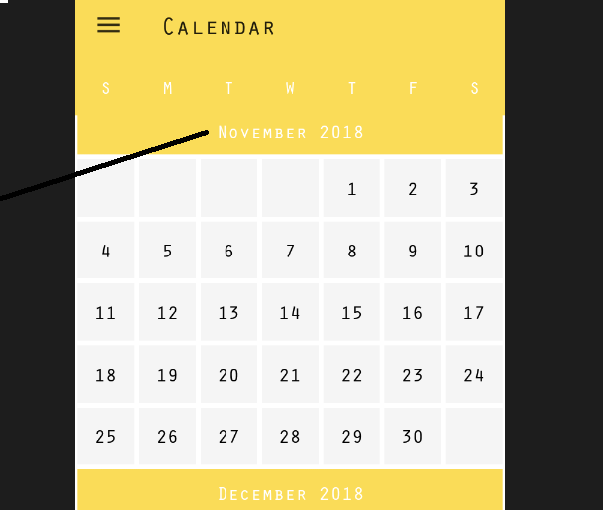
EXPECTED RESULT: Privious month & year should not visible.
PRIORITY : Medium
5.MODULE/PATH : REGISTRATION
BUG: In name folder max length allow.
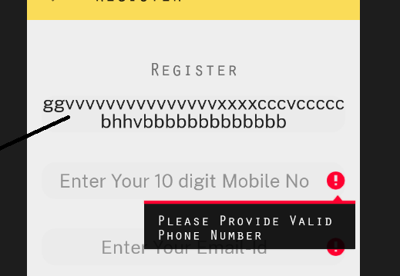

EXPECTED RESULT: In name folder max length should not allow.
PRIORITY : Medium
6. MODULE/PATH : REGISTRATION
BUG: In register page when we enter valid mobile number then display show a invalid phone number.

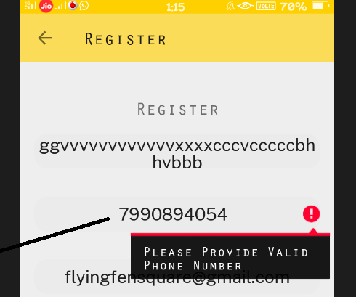
EXPECTED RESULT: Display should show valid number.
PRIORITY : Medium
7. MODULE/PATH : FAVOURITES
BUG: When we select favourites then it is not appear in favourites.
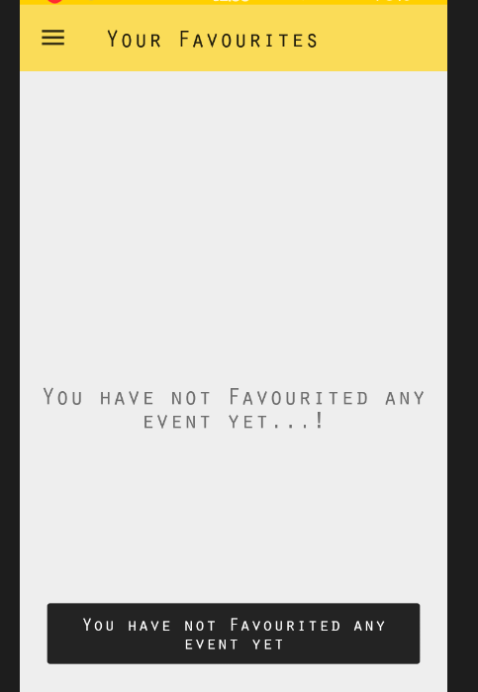
EXPECTED RESULT: Should appear in favourites.
PRIORITY : High
8. MODULE/PATH : PASSWORD
BUG : Allow max length.
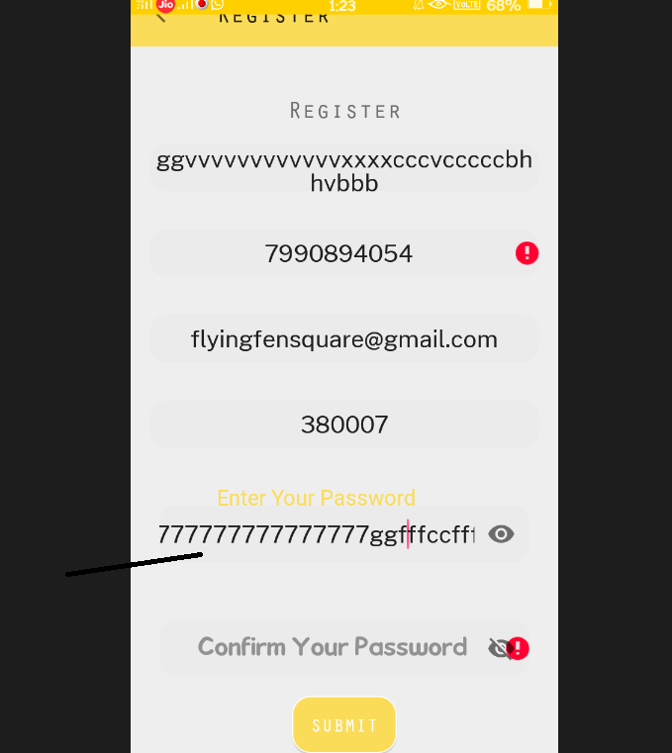
EXPECTED RESULT : Should not allow max length.
PRIORITY : Low
9.MODULE/PATH : HOME PAGE
BUG : Coming soon module not working properly.

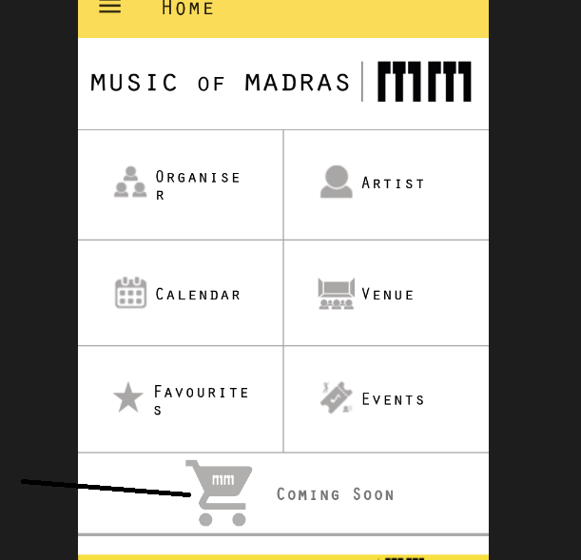
EXPECTED RESULT : Coming soon module should working properly.
PRIORITY : Medium
[LANDSCAPE MODE]
1.MODULE/PATH : HOMEPAGE
BUG: Home page is not appear properly.
EXPECTED RESULT : Should appear properly.
PRIORITY : Medium
2. Landscape mode is not working properly in all pages/module.
3.In landscape mode artist,organizer,venue,event,notification automatically converts in portrait mode.
[SUGGESTIONS]
1.In homepage all logo should colorfull.
2.In calendar sunday should highlight with another colour.

